|  |  |
| --- | --- |
| QUICK START API REST TANAGURU V0.1  Quickstart Api Tanaguru | Résumé  Use Api Tanaguru with a chrome extension  **Team Tanaguru** |

**Summary**

Quick start Guide 1

Installing a chrome extension 1

Request token 1

Invalidate a token 3

Launch a page audit 4

API USE STATISTICS 5

# Quick start Guide

## Installing a chrome extension

From a chrome browser, download [Advanced Rest client](https://chrome.google.com/webstore/detail/advanced-rest-client/hgmloofddffdnphfgcellkdfbfbjeloo)

Once installed, start the extension.

## Request token

Assuming that your Beta ID is: **b9025c56b2425053dc069585390ab7c8** and your

Beta Password is: **10ee8cf96f9e35f7207a9a5cb3f89ed63c5f59692e1782d82c7eb73d21067695**.

**Note:** For First Beta version of Tanaguru Api, we authorize 5000 requests for free.

**Note:** The authentication informations mentioned is only for beta version, this is a sample. Contact team Tanaguru to have a valid client ID and PIN (contact@tanaguru.com)

1. Enter the url for authentication: **https://api.tanaguru.com/v1.0/service/security/authenticate**
2. Choose the request method POST
3. Go to the tab **Headers form**
4. Add the parameter **Authorization**
5. Click to the « Edit » icone to set the parameter value **Authorization**
6. Enter your **customer ID** at User name, your **secret code** at Password, and click on select button.
7. Add the **Grant_type** parameter and give it the value **client_credentials**
8. Add the **Content-type** parameter and give it the value **application/json**
9. After entering all these informations, click send to apply.

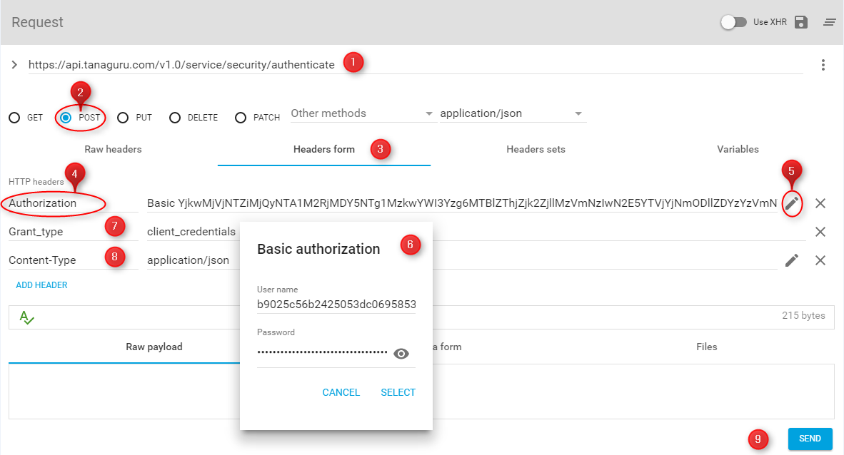

You will get the following answer:

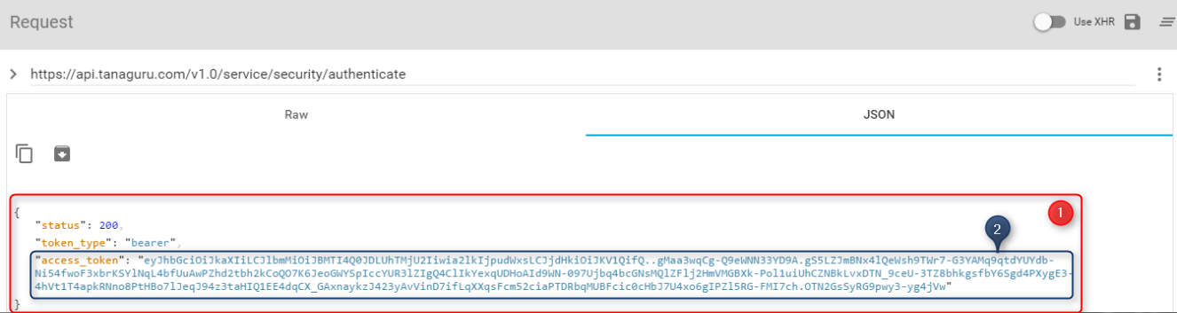

1. The answer contain informations about the answer **statut** and the **token** type
2. The token value that you will use to make audit requests.

**Note :** Keep the token generated to use it in the authentication for audit requests.

## Invalidate a token

After using the token, if you want disable it for any reason,

1. Enter the url authentication: **https://api.tanaguru.com/v1.0/service/security/invalidate_token**
2. Make a **POST** request,
3. Go to the tab **Headers form**
4. Add the parameter **Authorization**,
5. Click to the « Edit » icone to set the parameter value **Authorization**
6. Enter your **Customer** **ID** at User name, your **secret code** at Password, and validate.
7. Add the **Accept** parameter and give it the value **application/json ; charset=utf-8**
8. Add the **Content-type** parameter and give it the value **application/json**
9. Add the **access_token** parameter and enter the token that you want invalidate.
10. Click send to apply.

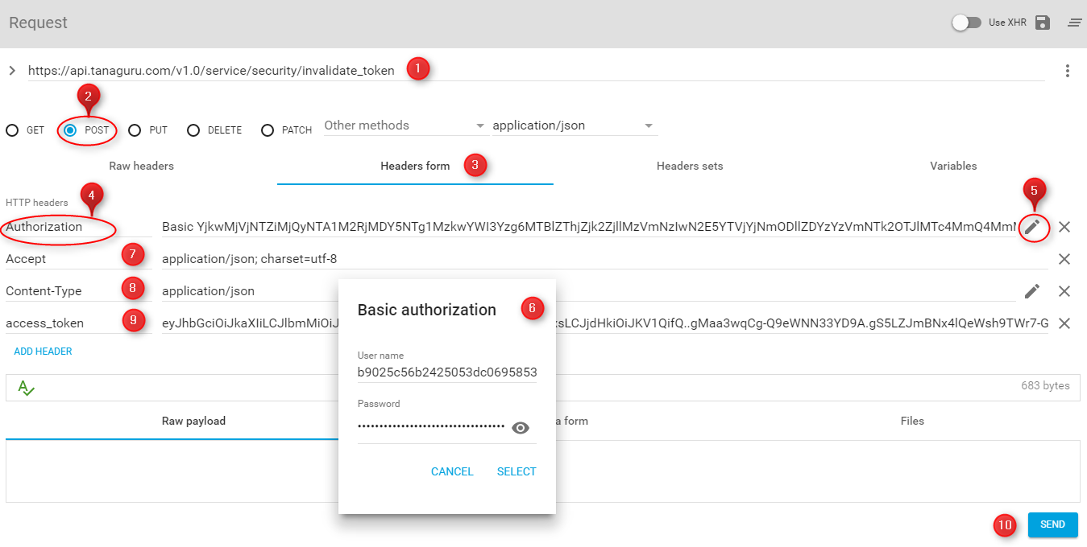

## Launch a page audit

To launch an audit on the site <http://www.oceaneconsulting.com> with all languages,

1. Enter the url authentication: **https://api.tanaguru.com/v1.0/service/auditPage**
2. Make a **POST** request,
3. Choose **application/json** as data type to send.
4. Go to tab **Headers form**
5. Add the parameter **Authorization**
6. Use the Token type **bearer** with your token as : **bearer eyJH...**
7. Add the parameter **Accept** and give it the value **\*/\***
8. Add the parameter **Content-type** and give it the value **application/json**
9. Got to tab **Raw payload**
10. Enter at the Json format **{"page_url" : "http://www.oceaneconsulting.com"}**, add the **language**, **referentiel** et **level** attributes is not required because they have a default value (All, Rgaa30, AA).
11. Click send to apply.

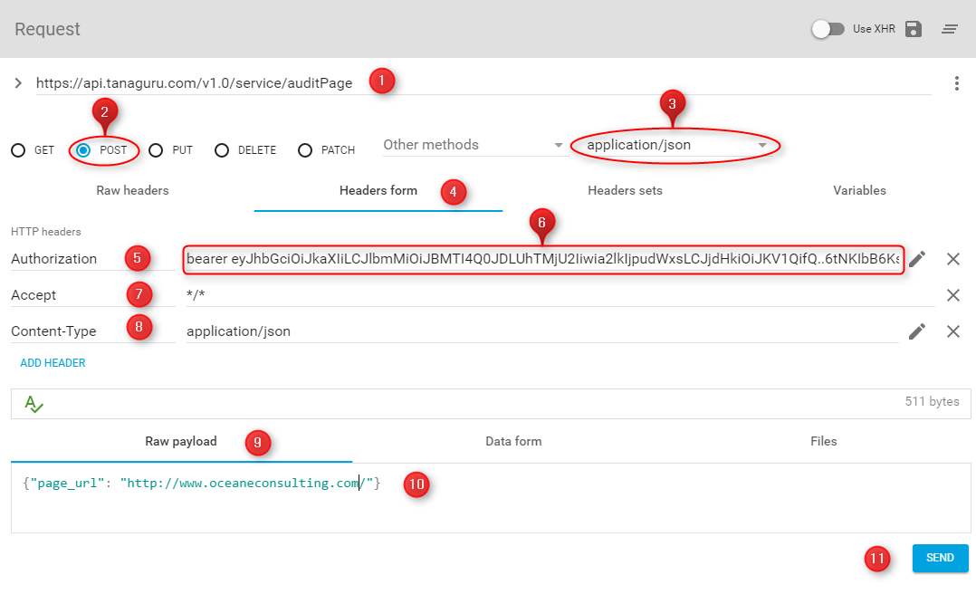

## API USE STATISTICS

To see API usage statistics with your account

1. Enter the url authentication: **https://api.tanaguru.com/v1.0/service/limit_stat**
2. Make a **GET** request
3. Go to tab **Headers form**
4. Add the parameter **Authorization**
5. Use the Token type **bearer** with your token as : **bearer eyJH...**
6. Add the parameter **Accept** and give it the value **\*/\***
7. Add the parameter **Content-type** and give it the value **application/json**
8. Click send to apply.
9. The answer contain the API usage informations.

